

**Simple Imaging. Tactial Triage. Zero Clicks.**

**Cipher Tech Solutions**

# USER MANUAL

Contents

USER MANUAL 1

About IO 1

Automatic Imaging 2

Manual Imaging 4

GUI Overview 6

Main Screen 6

Device Selection 7

Imaging 8

Advanced Options 9

Information 10

## About IO

IO is a zero-click tool which creates E01 format images from connected devices. IO displays live triage information while imaging, including GPS EXIF information found from image files and file count totals.

Upon completion, IO produces a series of E01 image files, a report and a CSV document of images with GPS EXIF information.

## Automatic Imaging

IO will automatically image devices connected after launch with zero clicks.

1. **Launch IO executable.**

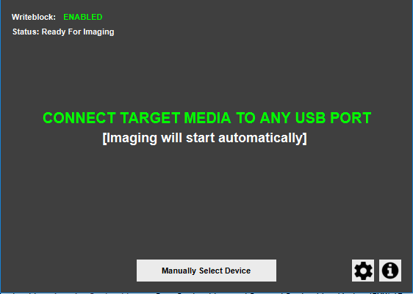

1. **Connect media to any USB port to begin imaging.**

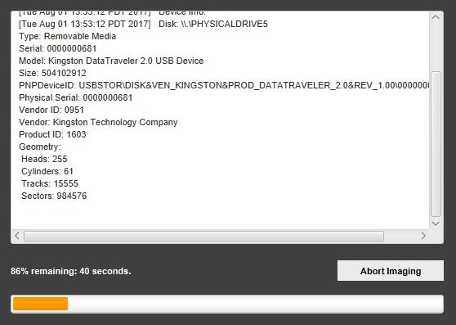

1. **IO will immediately, automatically begin imaging inserted media disk(s) and all partitions. If several disks are inserted they will be queued and imaged one after another.**
2. **Wait for IO to complete. Once *‘Imaging Completed Successfully’* prints, media can be disconnected.**

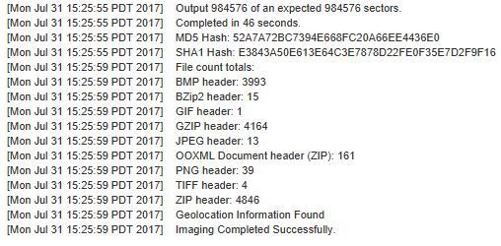

1. **Click ‘Return to Main’. IO is now ready to image again.**

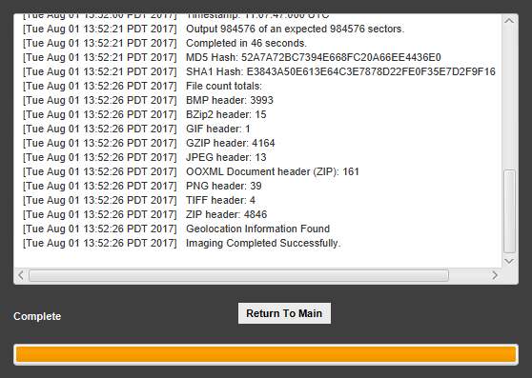

## Manual Imaging

IO also allows users to begin imaging by selecting from all connected devices.

1. **Launch IO executable.**



1. **Click *‘Manually Select Device’*.**

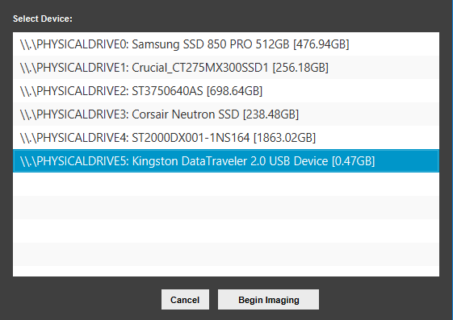

1. **Select a device from the list and click *‘Begin Imaging’.* IO will then image the selected disk and all partitions.**
2. **Wait for IO to complete. Once *‘Imaging Completed Successfully’* prints, media can be disconnected.**



## GUI Overview

### Main Screen



The Main first is the initial screen displayed after IO is launched. The screen indicates whether the USB write-block has been enabled, and informs the user imaging will start once a device is connected. Users can also click ‘manually select device’, options (the gear icon), or information. All other screens return to the main screen.

### Device Selection



If the user click ‘*Select Device Manually*’ they will be taken to the device selection screen which displays a list of currently connected devices. Devices show the path, name and size in GB. Users can click a device to selected it, then click ‘*Begin Imaging’* to start the image process.

### Imaging



Once imaging has begun, the imaging screen will be displayed, which shows processing about, a progress bar with percent and time remaining, as well as an ‘Abort Imaging’ button. The output will display timestamped information about the drive being imaging, including device details, GPS EXIF information, file counts, and bad sectors. A more verbose output is stored alongside the image file.

### Advanced Options

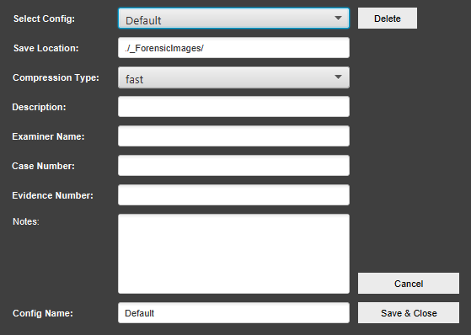

By clicking the gear icon on the main screen, users are brought to the advanced options screen. Here users can configure additional parameters and saved separate configuration files. The configuration specific options include changing the save location, and zip compression level. Other non-default information will be attached to the image’s report, such as description, examiner name, case number, evidence number, and notes. Users can then name and save separate configuration files.

### Information

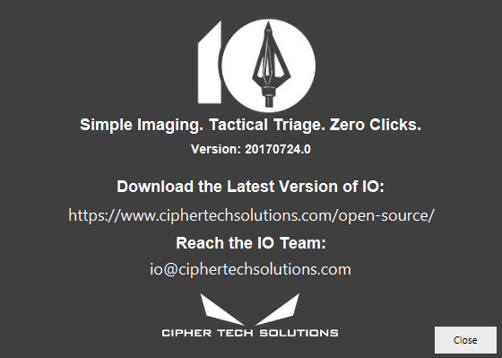

Click the information icon on the main screen displays info about IO and Cipher Tech Solutions. Users can find the version information, a link to Cipher Tech’s open source Github, and contact for questions about IO.